Chevrolet Company Project
Students Name
Institutional Affiliation

Chevrolet Company Project
EXECUTIVE SUMMARY
Our project focuses on the Chevrolet Company, which deals with the manufacturing and selling of vehicles. Vehicles industry is significant among many people since most people’s dreams include owning a fancy car in their lifetime. By focusing on a project that involves a company dealing with vehicles, facts of the car processing, and manufacturing industry brought to light. Our plan also brings to light vital concepts that contribute to the success of the Chevrolet Company. The history of the company is an essential part of providing a reliable analysis; hence our project also focusses on the history of Chevrolet Company.
We cannot shy away from the fact that the car manufacturing industry is one of the most successful. This concept makes many questions linger in many people's minds. Some of these questions are what factors do we have to consider to be successful in the car industry? What measures and concepts do we need to consider to be successful as Chevrolet? When and how did Chevrolet Company start? In consideration of the above questions, our project tends to answer such questions and other significant facts which people did not know about vehicle industries.
Additionally, the results of our project are fact-based. This concept ensures critically analyzing different ideas concerning the Chevrolet company and making conclusions as well as recommendations without favor. Through our findings, thoughts in which people may adapt and prove useful regarding business management are carefully examined. Chevrolet Company has been in existence for more than a century. It is a significant time, and there must be some inevitable facts that have contributed to Chevrolet's existence for such a long time. These facts are analyzed in our project. Furthermore, we cannot shy away from the fact that the Chevrolet Company produces all types of cars, which makes it an all-round company.
INTRODUCTION
History of the Company
Chevrolet Company, also popularly known as Chevy, was founded on November 3, 1911. It was first established in Detroit, Michigan. During the time of its establishment, there were fewer automotive companies, and this aspect made the company innovatively formulate their objectives. The co-founders of the company were Louise Chevrolet and William C Durant. Louise Chevrolet was the co-founder of Chevrolet Company, while William C Durant was the co-founder of the General motors company (Ashish et al., 2016). When the company was starting, it was known as the Chevrolet division of motors, where it was among the Americas division of automobile manufacturers.
Additionally, in 1916, Chevy debuted model 490. This was also a strategy to compete with Ford motor company. The operations of the company continued, and in 1926, Chevrolet Company debuted the Chevrolet six model. In this model, there was a six-cylinder engine for the price of a four-cylinder engine. This was a significant improvement by the company since, during this era, automotive industries were only offering four-cylinder engines (Ashish et al., 2016). Another major event occurred in 1950, where the company was the first to provide an automatic transmission. The automatic transmission is also known as power glide transmission and offered in lower-priced vehicles.
In the development process of the company, Sir Durant used the then Chevrolet motor company to get influence in General motors manufacturers. In 1918, a reverse merger in the automotive industry occurred, and this made Sir Durant the president of General Motors since it was one of his main objectives. Alfred Sloan picked the Chevrolet brand and made positive changes in the brand. This aspect made Chevrolet become a significant brand in general motors fraternity. In 1919, the Chevrolet brand had sold a vast number of vehicles, and it overtook its main competitor, which was the ford brand (Ashish et al., 2016). Before Chevrolet got to the market, ford was the most popular vehicle brand, thus making it the main competitor of the Chevrolet vehicle brand.
Chevrolet Company continued to make new brands as well as vehicle models, which made it a successful company in most parts of the world. Operations of Chevrolet Company are worldwide although it does not operate in some regions, for example, South Africa, Cuba, Hong Kong as well as South Asia. Relaunching of Chevrolet activities in Europe took place in 2005, and this aspect intensified the company’s operations in the European continent. Between 2007 and 2010, the company has introduced new car models. Through the introduction of new car models, the economic status of the company recovered (Rosner, 2016). This aspect is an important marketing strategy and helps stabilize the financial situation of the Chevrolet Company.
What are the services provided by the Chevrolet Company?
Chevrolet is in the automotive industry. Its products are commercial automobile cars with different models. Some of the vehicles manufactured by the company include trucks, sports cars, electric cars as well as classic cars. Through the manufacturing of all these cars models, it provides customers with a wide range of choices since they can be served based on their car model interest. Based on sports cars produced, the company sports car models participate in many sporting events all over the world (Rosner, 2016). An appropriate example of the events where Chevrolet sporting cars models are used includes Nasar sporting event, Indy car, as well as a world touring car championship.
Apart from offering car services, the Chevrolet Company offers car-related services. Some of the services provided by the company related to the vehicle industry include vehicle insurance services, provision of vehicle spare parts as well as offering financial assistance to car buyers. In the insurance covers, an interested party secures an insurance cover of bought product. This aspect provides for Chevrolet company sharing cost if the vehicle is damaged under compelling circumstances. Additionally, spare parts services are also an outstanding service offered by the company where some of the vehicle parts are sold to the customers at an affordable price (Chen et al., 2016). Some of Chevrolet's vehicles spare parts are hard to find in other firms, and to cater for their customer's needs, Chevrolet Company must produce spare parts for their products. Another outstanding service offered by the company is financial assistance to potential customers. Chevrolet Company provides loans to potential customers, and they agree on suitable terms for both parties.
The reason why we selected the Chevrolet Company
The main reason why we chose the Chevrolet Company was because of its success and existence for the longest time. Based on the background information of the company, it is evident that the company has been in existence for more than a century. Since its formation in 1911, the company has made significant changes as well as improvements in the automotive industry. Chevrolet has proven reliable since they manufacture their vehicles using an assembly line, which is relatable to the material we are learning in class.
Some of the important matters related to business management can be learned from the company. Additionally, a large number of group members have an interest in the car industry. This aspect is crucial since it made everyone was okay with the chosen topic. The products offered by Chevrolet company products are unique; hence it provides for studying and deducting essential principles in business operation. Chevrolet Company is also a world-class company, and for it to achieve customers around the globe, there had to be a reason behind it, thus made us more interested in studying the company.
Objectives of the team
- To learn the product and service of Chevrolet company.
- To learn the production process and six sigma qualities of our research company.
- Relate Operation management of the company with classwork.
ANALYSIS/ RESEARCH
From our class, Chevrolet, which is our company of choice, is related to chapter three, six, and nine. All three sections explain the company’s operations. Moreover, concepts from the three chapters present facts that enables us to get a better understanding of the Chevrolet Company. Based on chapters 3, 6, and 9, it allows us to achieve fact-based as well as reliable results. Chevrolet Company considers product and service design, which is a significant concept in chapter three. The company is also characterized by a production process, which is a significant concept discussed in section six, and also Chevy is characterized by six sigma qualities, which are concepts discussed in chapter nine (Chase et al., 2010). To get a better understanding of how the Chevrolet Company applies all the concepts in the three chapters, our group studied the three sections separately and deductions made.
PRODUCT AND SERVICE DESIGN
New Product Development
Chevrolet is characterized by motor vehicle products where these products are designed in a unique as well as distinct way from other companies. Since its establishment, the company has established new products, which are a result of evolution in the vehicle industry (Chase et al., 2010). The core purpose of developing new products is to accelerate the transformation of the company in the future. In 2015, the Chevrolet Company laid-out a strategy of how to create new cars that are in line with technology. The introduction of new vehicles would also cater to cost-effectiveness, which is among the significant concerns of the Chevrolet Company.
In the development of new cars, the Chevrolet company takes into consideration six different phases. In all these phases, the product passes under the different mechanisms to evaluate the suitability of the product. These phases involved by the Chevrolet Company are phase o, phase 1, phase 2, phase 3, phase 4, and phase 5. An appropriate example showing the development of a car that has undergone all these phases is the sports car, which is always manufactured by the company as new products (Chase et al., 2010). Consequently, the development of new products involves all parties in the Chevrolet Company, including the managing staff as well as workers. Through the cooperation of different parties in the company, a new product suitable for the market is developed.
Phase 0 central concept is planning. For the development of a new product by the Chevrolet Company, it begins with accessing technology development and the objectives of the market. In most cases, Chevrolet considers sporting cars, trucks, and fancy cars. For all these cars to be approved in Chevrolet, the mission is clearly stated, and it is parts of Phase 0. In phase 1, the concept of the car model is developed; the need for the market is evaluated wherein Chevrolet Company the market always demands high speed, more effective, and easily engaged cars. System-level design is the main idea of phase 2 (Chen et al., 2016). In this phase, the new car product is decomposed into subsystems, and this aspect provides for coming up with the most suitable product.
Details of the new design is a significant consideration of the Chevrolet Company. This aspect comprised of phase 3 of new product development. All the specifications of the new car developed including engine type, color, tires type, ignition system type as well as the type of stroke are outlined in these phases. In phase 4 of new product development, testing, and refinement of the new car are formulated. In Chevrolet, car testing occurs before authorization to be released in the market, and this concept helps the company reduce customer complaints as a result of faults experienced in the new product (Uddin et al., 2018). The final phase considered by Chevrolet is phase 5, which is product ramp-up. This process involves all Chevrolet workers, where any faults in the developed vehicle model are corrected.
Ideal Products
Chevrolet designs car models are based on customer need and not what the management of the company feel as appropriate for the design. Designing vehicles based on customers' needs is an essential factor in the production of ideal products. A suitable example, showing how Chevrolet company design product based on customers interest is the development of electric batteries as well as vehicles (Chase et al., 2010). Due to technological advancement, customers continue to request electric cars from Chevrolet Company, and they never disappoint.
Design for manufacturing is another crucial aspect catered for by Chevrolet when designing new products. Based on this manufacturing aspect, vehicle design is developed in a way that is easier to manufacture and an improvement from prior plans. This is a suitable marketing and relevance strategy employed by Chevy since it ensures manufactured vehicles are an improvement from previous models. The most effective design model adapted by Chevrolet is concurrent engineering, where different departments in Chevrolet Company work together.
Currently, most Chevrolet vehicles are designed for the environment. This aspect ensures that the car conserves the environment by not contributing to pollution. Environmental conservation is a primary concern by many vehicle manufacturing industries since they are the main contributors to environmental pollution. Air pollution by car is through the burning of fossil fuels used in vehicles. The produced fossil fuels emit carbon IV oxide, which results in global warming (Uddin et al., 2018). To cope up with environmental pollution problem, Chevrolet Company designs vehicle which emits less smoke as well as designing electric cars which do not emit smoke at all.
PRODUCTION PROCESS
Project
For accountability and easy monitoring of the vehicles produced, production remains in a specific location. Some of the centers where Chevrolet vehicles are manufactures include Arlington assembly in Texas USA, Bogota plant in Colombia, Bowling Green Assembly in Kentucky, and the flint truck assembly in Michigan (Chase et al., 2010). All these assemblies are specialized in specific vehicle models. The main advantage of carrying out a project in a fixed location is to facilitate the easy assembling of materials. Manufacturing equipment is assembled to the manufacturing plant, also employing the techniques of project management.
Arlington assembly in Columbia majorly produces SUVs models. These models are the most successful having many customers. Bogota plant in Colombia is specialized in the production of Aveo Hatchback and Sedan models (Uddin et al., 2018). The Aveo hatchback model is fuel-efficient, and through production in one location, assembling of manufacturing materials is smooth. The customers can always rely on the plant for the production of similar products. In Flint truck assembly in Michigan, trucks are the primary vehicles to be manufactured by Chevrolet. The production process in this assembly ensures for production of heavy trucks that always have a vast market not only in Michigan but also to other parts of the world.
Through the production of Chevrolet products in fixed locations, the company can sustain financial crises that may affect the general motors manufacturers. Chevrolet company is part of General motors manufactures, but it was able to maintain its financial status even after General motors experienced bankruptcy (Kapitonov, 2017). This aspect was likely to affect Chevrolet, but due to project management and production process in specific areas, it was possible to monitor the sales, manufacturing as well as the assembling process. This strategy in the production process enabled Chevrolet to survive the bankruptcy incident.
WorkCentre
Chevrolet company group together similar equipment and functions. The primary purpose of assembling similar services is to optimize the movement of materials. Accountability is a crucial consideration of the Chevrolet Company. Similar cars, for example, heavy trucks, are collected in the same car assembly in Michigan. Monitoring of vehicles that leave the assembly is easy since heavy all heavy trucks of Chevrolet Company are gathered in this specific location.
Additionally, Chevrolet understands one of the basic principles of accountability of both production and sales processes. If, for example, rucks are located in different assemblies within different Chevrolet firms in the USA, it would be hard to know the number of trucks sold or produced. Lack of accountability is a significant cause of bankruptcy in the automotive industry, and Chevrolet effectively understands this aspect. It has enabled Chevrolet to be in existence for the longest time. There is a smooth production process when dealing with similar types of commodities, unlike when dealing with different kinds of products.
Manufacturing Cell
Manufacturing cell is an important aspect of production processes carried out by the Chevrolet Company. In manufacturing cells, a similar grouping of products which have identical processing requirement is the primary operation. Chevrolet Company carries these operations through assembling vehicles with similar processing processes in the same assemblies. An appropriate example explaining this aspect is where Chevrolet company groups together sporting cars. These sporting cars by Chevrolet are meant for the same purpose but are used in different geographical locations, thus requiring some minimal differences (Giri et al., 2017). The production process of sporting cars is similar; thus, physically regrouped into cells, an aspect which represents the aspect of manufacturing cells.
Assembly Design
It is also an essential part of the production process in the Chevrolet Company. Assembly line design refers to the arranging of work processes according to the progressive steps by which the products are made. Although other car manufacturing companies employ this strategy, we cannot shy away from the fact that Chevrolet has a unique assembly line design. One of the aspects which makes assembly line design in Chevrolet unique is because of using current technology (Giri et al., 2017). Robots are used in Chevrolet car assemblies, for example, in Texas Chevrolet car assembly. Robots are technological machines that work at a faster rate, can lift heavy machines as well as accuracy in the work they are designed for. This makes Chevrolet have an advantage over other car manufacturing companies since there are very few mistakes made when assembling this equipment.
Continuous Process
For better service delivery to the customers, Chevrolet adopts a continuous production process. This aspect ensures that customers are always served with new as well as more developed vehicles from the company. The continuous production process ensures that the company does not run out of stock. However, the Chevrolet Company regulates the continuous production process to check for overproduction the same vehicle model. The continuous production process is closely related assembly line, but the flow is constant. The continuous production process also provides for the production of high-quality products since the same production formula is applied to all the vehicles produced.
SIX SIGMA QUALITY
Chevrolet Company effectively employs concepts discussed in chapter 9 of classwork. In this chapter, the main ideas are Quality and total quality management and Six Sigma techniques. During our project, a closer examination of all these aspects enabled us to get a better understanding of operations in the Chevrolet Company (Chase et al., 2010). It gave us a broader understanding of the kind of defects faced by Chevrolet Company and how it eliminates these defects and secure its position of being among the leading car manufacturing company.
Quality and Total Quality Management
Quality and total quality management can be treated as two separate terms, but their functions are closely related to one another. Chevrolet uses different techniques in ensuring the maintenance of quality and quality management of all its products. Customers are significant stakeholders in the Chevrolet Company since they provide a market on the company’s product. Based on this concept, the quality of different models of vehicles manufactured by Chevrolet Company is determined by customers where the management of the company treats customer’s information with high regard (Toma et al., 2017). Customers range Chevrolet companies’ products based on vehicle performance, features, the durability of the car, serviceability as well as perceived quality. All these aspects are determined through customer feedback.
To evaluate the company’s product, the Chevrolet Company uses different methods in collecting information feedback from the customer. Methods used to solicit customers' feedback on the products of the company include the use of social media, carrying out surveys, as well as usability tests. Chevrolet Company has social media pages on Facebook, Instagram, as well as on twitter. All these platforms are open for suggestions (Chase et al., 2010). Many customers use this platform to express their views on the quality of Chevrolet products. Furthermore, the company has a team that analyses customers' responses, and the company works towards them. The company also conducts surveys through emailing customers. Chevrolet requests permission from customers before emailing them requesting their view on a specific product. A usability test is carried out where customers give their opinion directly to the company regarding the usability of the produced products (Toma et al., 2017). Through a closer examination of customers' responses, Chevy can meet fundamental operational goals which are, carefully designing a car product and ensuring that the company can consistently produce this product.
Total quality management is another crucial aspect considered by Chevrolet. In overall quality management, Chevy considers three philosophical principles, which are Customer satisfaction, the involvement of employees as well as continuous improvement performance. Customer satisfaction in the company is ensured by responding to some of their significant concerns from customers' feedback. For the quality of a product to be of high quality, Chevrolet Company understands that the involvement of the employee is a crucial factor. Employees are involved through the sharing of the company's ideas as well as making them feel like part of Chevrolet Company rather than employees. They are also offered generous allowances, salaries as well as retirement terms. This ensures employees' needs are catered for, and this aspect results in the production of high-quality products. Furthermore, the company always works to introduce new vehicle models that are in line with current technology.
Six sigmas’ (methods companies use to eliminate defects)
Just like any other company, Chevrolet encounters several defects as well as problems. Some of the shortcomings experienced from Chevrolet vehicles include hesitation while shifting the car, defaults in airbags, leaking of engine oils as well as clunking engine noise. To deal with the defects as mentioned above, Chevrolet employs the six-sigma methodology to deal with defects. Additionally, six sigma methodology is based on statistical measures that help in equating available errors to a wide range of opportunities (Kozlovskiy et al., 2017). This methodology comprises five main parts which are defining the defect, measuring it, defect analysis, improvement, and control phase.
In defining the defect, Chevrolet identifies the car model having the defect, for example, failure of airbags in sporting cars. Through knowing the type of defect and in which car model, Chevrolet company can know the suitable approach when dealing with the problem. The measuring process is an important part of six sigma methodology and effectively applied by Chevy when dealing with defects in their car models (Kapitonov, 2017). After measuring the extent to which a certain problem has failed analysis process then follows. In airbag failures analysis showed that defect cause was as a result of many commands as well as engagements through which sporting cars were subjected to. Airbags were initially designed to function when few car systems were engaged hence their failure in sports cars.
The improvement phase, which is part of six sigma methodology follows the analysis phase. Chevy works on the defects where it minimizes them in their new car models. Moreover, the improvement phase provides a chance for the company not to release car models that have the same defects to their customers. In the case of failing airbags in sporting cars, the company repaired all cars which were manufactured at the same time with those that had failed airbags (Kapitonov, 2017). Control is the final part of defect control methodology, and it involved maintaining improvements already made. Chevrolet continues to develop car models in which the initially discovered defects are carefully considered.
CONCLUSION/ RECOMMENDATION/ OPINIONS
Conclusion
From the project, it is evident that the Chevrolet Company, which deals with automotive fits the global market. The company also effectively employs most business management principles, which ensures its success as well as being one of the dominant vehicle manufacturing company. Based on the above-provided data, about 75% of all vehicle sales came from USA major stakeholders being the Chevrolet Company. This aspect indicates the success level of the company. It is also evident that the products and services offered by the company are in line with technological advancement in the world. Although other companies also use some business management strategies used by Chevy, the company uniquely implements them.
Chevy had been in existence for more than a century, and changes carried out on the company being gradual. This aspect has a significant effect and lesson to newly established businesses. Chevrolet Company neither started with a vast number of customers nor many car assemblies, but all these achievements took time. In the current world, many businesses want agile development and fast accumulation of profit without first learning important business concepts. This perspective is the main reason why main businesses are failing, running bankrupt over a short period.
Additionally, Chevy being a large company, does not mean that small businesses cannot borrow business concepts. Business management strategies employed by the company are applicable in any business regardless of the size. It is also evident that challenges and defects are part of business operations. Through our project, we discovered Chevrolet also faces challenges but applies effective measures that enable the company to overcome these challenges.
Recommendation
Based on our project, our major concern is on revenue imposed on car manufacturing companies. Although taxes from car manufacturing firms contribute to the gross domestic product of the nation, some of the imposed taxes are too high. The imposition of high taxes on car manufacturing firms leads to a financial crisis in these companies leading to bankruptcy. The area we feel needs more attention by government institutions responsible for car manufacturing as well as other stakeholders in the automotive industry is on taxes issue. The imposition of high taxes kills the dream of many potential entrepreneurs in the automotive industry.
Our Opinion
Should Chevrolet Company carry out a mentorship program countrywide for young entrepreneurs? This was the main question that lingered on the mind of our group. This question was raised due to the success of Chevy motor company and existence in vehicle manufacturing for over a century. Our opinion was that the company should be licensed to carry out the mentorship program. The program should not carry out to entrepreneurs only but also educational institutions such as colleges, and this will make more students creative as well as innovative.

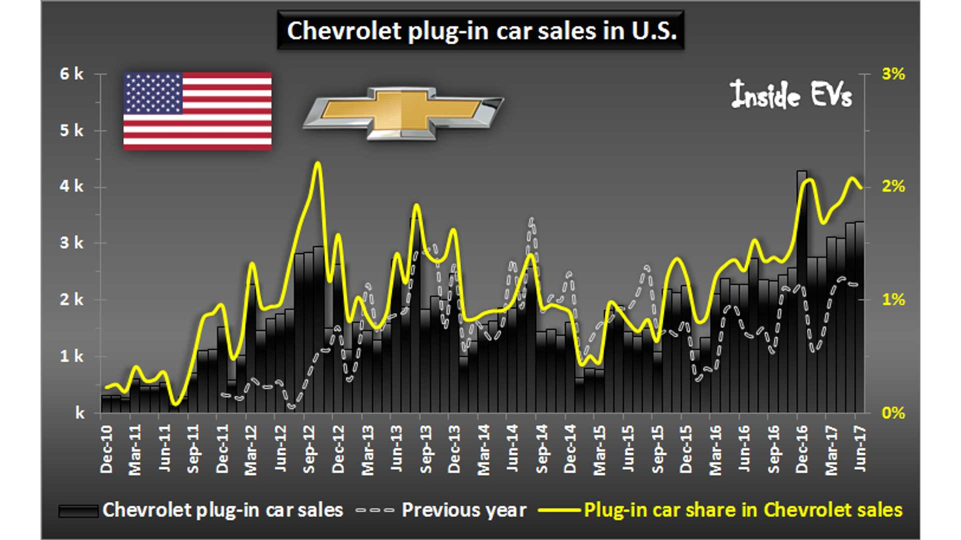
A graph showing Chevy sales between December 2010 and June 2017
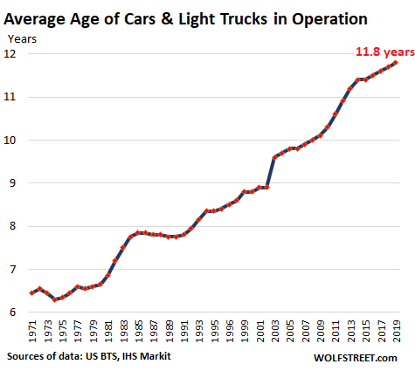
Data showing all operational age of operational cars manufactured by Chevrolet

References
Ashish, K., & Kabugade, R. R. (2016). Study the Sales of Chevrolet Vehicles along with Customer Satisfaction with reference to Pandey Motors Pvt. Ltd., Patna. A Journal of research articles in management science and allied areas (refereed), 9(2), 38-44.
Chase, R., Shankar, R., & Jacobs, F. R. (2010). Operations and Supply Chain Management, 14e. McGraw-Hill Education.
Chen, T. D., Kockelman, K. M., & Hanna, J. P. (2016). Operations of a shared, autonomous, electric vehicle fleet: Implications of vehicle & charging infrastructure decisions. Transportation Research Part A: Policy and Practice, 94, 243-254.
Giri, B. C., Roy, B., & Maiti, T. (2017). Multi-manufacturer pricing and quality management strategies in the presence of brand differentiation and return policy. Computers & Industrial Engineering, 105, 146-157.
Kapitonov, V. (2017). U.S. Patent Application No. 29/545,190.
Kozlovskiy, V., & Aydarov, D. (2017). Analytical models of mass media as a method of quality management in the automotive industry. Calitatea, 18(160), 83.
Rosner, D. (2016). Flint, Michigan: a century of environmental injustice.
Toma, S. G., & Naruo, S. (2017). Total quality management and business excellence: the best practices at Toyota Motor Corporation. Anfiteatro Economic Journal, 19(45), 566-580.
Uddin, K., Dubarry, M., & Glick, M. B. (2018). The viability of vehicle-to-grid operations from battery technology and policy perspective. Energy Policy, 113, 342-347.

